
Ministry of Higher Education
Thebes Academy
Thebes Higher Institute for Computer and Management Sciences

Pais: Pharmaceutical Artificial Intelligent System
By
1. Amr Khaled Mohammed Ismail Kira
2. Amr Khaled Ahmed Radwan Hassan
3. Ahmed Alaa Eldin Abdo Mostafa
4. Abd Elrahman Mohammed Hussynie
5. Nouran Karam Ali Gad
6. Veronia Kamel Adly Kamel
Supervisor
Dr. Khaled Abdelrahman
A graduation project is submitted to the Computer Science Department in partial fulfillment of the requirements for the degree of Bachelor of Computer Science, Thebes Higher Institute for Computer and Management Sciences.
Cairo, Egypt
2025/2026
Ministry of Higher Education
Thebes Academy
Thebes Higher Institute for Computer and Management Sciences

BONAFIDE CERTIFICATE

Ministry of Higher Education
Thebes Academy
Thebes Higher Institute for Computer and Management Sciences
Certified that this project Documentation Pais is the bonafide work of:
1. Amr Khaled Mohammed Ismail Kira
2. Amr Khaled Ahmed Radwan Hassan
3. Ahmed Alaa Eldin Abdo Mostafa
4. Abd Elrahman Mohammed Hussynie
5. Nouran Karam Ali Gad
6. Veronia Kamel Adly Kamel
WHO CARRIED OUT THE PROJECT WORK UNDER MY SUPERVISION.
SIGNATURE  HEAD OF THE DEPARTMENT | SIGNATURE  SUPERVISOR
Ministry of Higher Education
Thebes Academy
Thebes Higher Institute for Computer and Management Sciences


Ministry of Higher Education
Thebes Academy
Thebes Higher Institute for Computer and Management Sciences

EVALUATION CERTIFICATE
[1] Evaluation of the chairman of the graduation project Committee:
Prof. ..........................................................................
This project Documentation is accepted as it is.
This project Documentation is rejected and I recommend the following modifications/editing to be accepted.
This project Documentation is rejected and I recommend to be repeated.
[2] Eligibility of the project Documentation to be added to institution library:
Eligible
Eligible after modifications
Not Eligible
[3] Comments/suggestions:
Date: _____________________

ACKNOWLEDGMENTS
First and foremost, we would like to thank the supervisor of our committee, Dr. Khaled Abdelrahman, for his support, outstanding guidance and encouragement throughout our senior project.
We would also like to express our gratitude and appreciation to all professors for all the help and guidance they provided throughout our education, and to assistants for all their advices to us during our education.
We would like to thank our family, especially our parents, for their encouragement, patience, and assistance over the years. We are forever indebted to our parents, who have always kept us in their prayers.
Special thanks and appreciation to our colleagues who have helped us or advised us or even just smiled at us, thank you all you have been a great asset to us.

ABSTRACT
The healthcare retail sector frequently struggles with supply chain disconnects, resulting in patients spending excessive time locating critical medications and pharmacies suffering from inefficient inventory management due to unpredictable local demand. The Pharmaceutical Artificial Intelligent System (PAIS) is a comprehensive digital healthcare platform designed to bridge this gap between medication supply and patient demand. PAIS operates as a unified, dual-module web application that seamlessly connects patients with pharmacies while equipping pharmacists with advanced tools to optimize their retail operations.
For patients, PAIS revolutionizes the medication discovery process. The platform features a location-based search engine that leverages complex geospatial database queries to instantly identify nearby pharmacies carrying specific, in-stock medications. Crucially, if a required medication is unavailable, PAIS utilizes a semantic search engine powered by Natural Language Processing (NLP) and Python-generated vector embeddings to recommend highly accurate, clinically viable pharmaceutical alternatives based on active ingredients.
For pharmacy staff, PAIS serves as a robust management portal. It streamlines inventory control through real-time tracking and bulk CSV upload capabilities. Beyond basic management, the system provides an advanced, AI-driven analytical dashboard. By employing machine learning algorithms, specifically the XGBoost algorithm, PAIS processes historical search logs and inventory data to forecast hyperlocal market demand, alert pharmacists to critical stock shortages, and highlight potential market opportunities through geographic heatmaps.
Technically, PAIS is engineered on a modern, scalable decoupled architecture. It utilizes the MERN stack (MongoDB, Express.js, React.js, Node.js) for robust backend logic, secure role-based access control, and dynamic frontend presentation. Intensive computational tasks, such as semantic similarity matching and demand prediction, are delegated to a dedicated Python FastAPI microservice to ensure high performance and low latency without slowing down the primary user gateway. Ultimately, the main contribution of PAIS is the creation of a transparent, data-driven pharmaceutical ecosystem that enhances medication accessibility for patients, modernizes retail pharmacy operations, and provides a scalable blueprint for integrating artificial intelligence into healthcare logistics.

KEYWORDS
Artificial Intelligent System – Real-Time Medicine Search – Geospatial Tracking – AI Alternative Recommendations – Pharmacy Inventory Management – Predictive Demand Forecasting – MERN Stack – Python FastAPI – Machine Learning – Healthcare Supply Chain

TIMELINE
Sprint | Duration | Activities
Sprint 1 | Weeks 1–3 | Project kickoff, Requirement gathering, System analysis, Feasibility study
Sprint 2 | Weeks 4–7 | System design, Architecture design, Database schema, UML diagrams
Sprint 3 | Weeks 8–9 | Backend development: Setup Node.js/Express, Database configuration
Sprint 4 | Weeks 10–11 | Backend development: API endpoints, Authentication, Inventory management
Sprint 5 | Weeks 12–13 | Frontend development: React setup, UI components, Design system
Sprint 6 | Weeks 14–15 | Frontend development: Search interface, Map integration, User dashboard
Sprint 7 | Weeks 16–17 | AI integration: FastAPI setup, Model training, Alternative drug recommendations
Sprint 8 | Weeks 18–19 | Integration testing, Performance optimization, Bug fixing
Sprint 9 | Weeks 20–21 | User testing, Refinement, Final deployment preparation
Sprint 10 | Week 22 | Final deployment, Documentation completion, Project presentation

TABLE OF CONTENTS

Pais: Pharmaceutical Artificial Intelligent System 1
BONAFIDE CERTIFICATE 1
EVALUATION CERTIFICATE 3
ACKNOWLEDGMENTS 4
ABSTRACT 5
KEYWORDS 6
TIMELINE 6
TABLE OF CONTENTS 7
LIST OF FIGURES 7
LIST OF TABLES 9
LIST OF ABBREVIATIONS 10
CHAPTER ONE | INTRODUCTION 11
1.1 Overview 12
1.2 Problem Definition 12
1.3 Proposed Solution 12
1.4 Aims and Objectives 12
1.5 Challenges 12
1.6 Timeline 13
1.7 Documentation Overview 13
CHAPTER TWO | LITERATURE REVIEW 14
2.1 Overview 14
2.2 Theory and Practice 14
2.3 Related Work 14
2.4 Aggregator Platforms 14
CHAPTER THREE | SYSTEM ANALYSIS 16
3.1 Overview 16
3.2 Gathering Requirements 16
3.3 User Requirements 16
3.4 System Requirements 17
3.5 System Analysis 17
3.6 Implementation Methodologies 19
CHAPTER FOUR | SYSTEM DESIGN 20
4.1 Over view 20
4.2 System Design 21
4.3 Object Oriented Approach 22
4.3.1 Use Cases 22
4.3.2 Sequence Diagrams 25
4.3.3 Activity Diagrams 34
4.3.4 Class Diagram 41
4.3.5 ERD Diagram 43
CHAPTER FIVE | SYSTEM IMPLEMENTATION 44
CHAPTER SIX | TESTING 45
6.1 Overview 46
6.2 System Testing 46
6.2.1 Unit Testing 46
6.2.2 Integration Testing 46
6.3 User Testing 46
6.4 Testing Summary 46
CHAPTER SEVEN | CONCLUSION & FUTURE WORK 47
7.1 Overview 47
7.2 Conclusion 47
7.3 Future Work 47
REFERENCES LIST 48
Format Examples: 48
END OF DOCUMENT 48

LIST OF FIGURES
Figure Name | Page
Fig 1: Usecase Diagram to Authentication & Identity | 21
Fig 2: Usecase Diagram to Onboarding, Inventory & Governance | 21
Fig 3: Usecase Diagram to Client Drug Discovery Portal | 22
Fig 4: Sequence Diagram to User Registration | 22
Fig 5: Sequence Diagram to Login, and Security Gatekeeping | 22
Fig 6: Sequence Diagram to Client Medicine Search | 23
Fig 7: Sequence Diagram to Geofenced Stock Locator | 23
Fig 8: Sequence Diagram to AI Alternatives | 23
Fig 9: Sequence Diagram to Pharmacy AI Dashboard | 24
Fig 10: Sequence Diagram to Pharmacy Inventory | 24
Fig 11: Sequence Diagram to System Admin License Auditing | 24
Fig 12: Sequence Diagram to Admin Master Catalog Synchronization | 25
Fig 13: Activity Diagram to User Onboarding and Registration Process | 25
Fig 14: Activity Diagram to Role-Based Login and Security Verification | 25
Fig 15: Activity Diagram to Client Activity Routing | 26
Fig 16: Activity Diagram to Pharmacist Multi-Lane Dashboard | 26
Fig 17: Activity Diagram to Pharmacies manage | 27
Fig 18: Activity Diagram to Drugs data mange | 27
Fig 19: Activity Diagram to AI training manage | 28
Fig 20: Class Diagram to Core Data models | 28
Fig21: Class Diagram to Auth & Security
Fig22: Class Diagram to Search & AI
Fig23: Class Diagram to Inventory & AI
Fig24: ERD Diagram to System Database

LIST OF TABLES
Table Name | Page
Table 1: Comparative Analysis of Existing Systems | 6
Table 2: Hardware Requirements | 26
Table 3: Software Requirements & Dependencies | 26
Table 4: Tools and Techniques | 27
Table 5: API Documentation Summary | 28
Table 6: Unit Testing Results Summary | 31
Table 7: Integration Testing Results | 32
Table 8: Performance Metrics | 33

LIST OF ABBREVIATIONS
Abbreviation | Term
PAIS | Pharmaceutical Artificial Intelligent System
SDLC | System Development Life Cycle
AI | Artificial Intelligence
ML | Machine Learning
NLP | Natural Language Processing
XGBoost | Extreme Gradient Boosting
MERN | MongoDB, Express.js, React.js, Node.js
REST | Representational State Transfer
API | Application Programming Interface
JWT | JSON Web Token
RBAC | Role-Based Access Control
FastAPI | Python Web Framework
Mongoose | MongoDB ODM Library
UI | User Interface
UX | User Experience
SPA | Single Page Application
OOP | Object-Oriented Programming
ERD | Entity-Relationship Diagram
CSV | Comma-Separated Values
GPS | Global Positioning System
2dsphere | 2D Sphere Geospatial Index
HTTP | HyperText Transfer Protocol
JSON | JavaScript Object Notation

CHAPTER ONE | INTRODUCTION

1.1 Overview
The Pharmaceutical Artificial Intelligent System (PAIS) is a comprehensive digital healthcare platform designed to bridge the gap between medication supply and patient demand. By leveraging modern web technologies, geospatial tracking, and artificial intelligence, PAIS transforms how patients locate necessary medications and how pharmacies manage their inventory in a highly dynamic market.

1.2 Problem Definition
The current pharmaceutical supply chain faces significant disconnects at the retail level. Patients frequently experience the frustration of visiting multiple pharmacies to find critical medications, resulting in wasted time and potential health risks. Conversely, pharmacies suffer from operational inefficiencies, often overstocking low-demand items while understocking essential medicines due to a lack of real-time market visibility and predictive demand forecasting.

1.3 Proposed Solution
PAIS proposes a unified, dual-module web application. For patients, it offers a location-based search engine to instantly find nearby pharmacies carrying specific medications, alongside an AI-powered recommendation system for clinically viable alternatives if the primary drug is out of stock. For pharmacies, it provides a robust management portal featuring real-time inventory tracking, CSV bulk-upload capabilities, and an advanced analytical dashboard that utilizes machine learning to predict local demand and highlight market opportunities.

1.4 Aims and Objectives
The primary aims of this project include:
- Enhancing medication accessibility for patients through real-time, location-based inventory tracking.
- Optimizing pharmacy operations by providing AI-driven stock forecasting and market insights.
- Implementing a secure, scalable Client-Server architecture utilizing the MERN stack and Python FastAPI.
- Developing a semantic search engine using natural language processing to identify accurate pharmaceutical alternatives based on active ingredients.

1.5 Challenges
Developing PAIS involves navigating several technical and operational challenges. These include ensuring minimal latency when executing complex geospatial database queries, seamlessly integrating a Python-based machine learning engine with a Node.js backend, maintaining strict data synchronization between concurrent inventory updates, and designing an intuitive user interface that accommodates both medical professionals and general users.

1.6 Timeline
The project follows an Agile Software Development Life Cycle (SDLC) segmented into consecutive phases: Requirement Gathering and Feasibility Study (Weeks 1-3), System Analysis and Architectural Design (Weeks 4-7), Iterative Back-End and Database Implementation (Weeks 8-12), Front-End Development and AI Integration (Weeks 13-18), followed by rigorous System Testing, Refinement, and Final Deployment (Weeks 19-22).

1.7 Documentation Overview
THIS PROJECT INTRODUCES SEVEN MAIN CHAPTERS AS FOLLOWS:
- CHAPTER ONE: Introduction - Outlines the project's background, problem statement, proposed solution, objectives, and overall structure.
- CHAPTER TWO: Literature Review - Examines existing systems, theoretical frameworks, and related technologies in the pharmaceutical and AI domains.
- CHAPTER THREE: System Analysis - Details the functional and non-functional requirements, data modeling, and end-to-end architectural flow of the system.
- CHAPTER FOUR: System Design - Focuses on the user interface (UI), user experience (UX), and detailed database schema designs.
- CHAPTER FIVE: Implementation - Describes the core coding practices, frameworks utilized (MERN, FastAPI), and the integration of machine learning models.
- CHAPTER SIX: Testing and Evaluation - Presents the testing methodologies, performance metrics, and validation of the AI models and API endpoints.
- CHAPTER SEVEN: Conclusion and Future Work - Summarizes the project's achievements and outlines potential future enhancements and scalability features.

CHAPTER TWO | LITERATURE REVIEW

2.1 Overview
This chapter explores the theoretical foundations and existing practical applications relevant to the Pharmaceutical Artificial Intelligent System (PAIS). It investigates the evolution of pharmacy management systems, the application of machine learning in demand forecasting, and the use of natural language processing for medical data retrieval. By analyzing current literature and related software solutions, this chapter establishes the context and justifies the technological choices made for PAIS.

2.2 Theory and Practice
The integration of technology into healthcare supply chains has traditionally focused on large-scale logistics and Enterprise Resource Planning (ERP) systems. However, the retail pharmacy sector is undergoing a digital transformation. In practice, modern systems are shifting from localized, monolithic databases to cloud-based architectures capable of real-time data synchronization. Theoretically, the application of predictive analytics—such as the XGBoost algorithm utilized in PAIS—allows for the processing of historical search logs and inventory deltas to forecast localized demand. Furthermore, advancements in Natural Language Processing (NLP) and Vector Embeddings (e.g., SentenceTransformers) provide the theoretical basis for calculating semantic similarities between drug compositions, enabling systems to suggest highly accurate, clinically relevant alternatives.

2.3 Related Work
To contextualize the proposed system, several prominent digital healthcare platforms operating within the Egyptian market were analyzed to understand their strengths and operational limitations.

2.4 Aggregator Platforms
1. Vezeeta: Originally a doctor-booking application, Vezeeta expanded into pharmaceutical delivery.
- Strengths: It possesses a massive, established user base and seamlessly integrates teleconsultations with immediate e-prescriptions and delivery.
- Limitations: Vezeeta acts strictly as an aggregator and does not typically interface directly with a pharmacy's live database. Consequently, the app does not show guaranteed real-time inventory.
2. Yodawy: A leading digital pharmacy platform that partners with independent pharmacies and major insurance providers.
- Strengths: Yodawy excels at insurance integration, allowing users to claim medications directly through the app.
- Limitations: Real-time stock visibility for immediate, cash-paying users can be opaque.
3. Chefaa (شفاء): An AI-powered, GPS-enabled platform focused heavily on the patient experience.
- Strengths: Offers strong patient-centric features including medication reminders and 24/7 chat.
- Limitations: Relies heavily on partner pharmacies to manually update inventory.

CHAPTER THREE | SYSTEM ANALYSIS

3.1 Overview
This chapter presents a comprehensive system analysis of the Pharmaceutical Artificial Intelligent System (PAIS). It serves as the bridge between the initial problem definition and the technical blueprint required for development.

3.2 Gathering Requirements
The requirements for PAIS were gathered through a systematic analysis of the existing pharmaceutical supply chain challenges, particularly the disconnect between pharmacy inventory levels and patient accessibility. The process involved identifying the primary stakeholders: Patients seeking reliable medication availability, Pharmacists requiring efficient inventory management and market insights, and Administrators ensuring system integrity. By analyzing these distinct perspectives, the core functionalities necessary to bridge the gap between supply and demand via real-time data, geospatial tracking, and predictive machine learning were identified.

3.3 User Requirements
User requirements define the specific tasks and goals that the primary actors must be able to accomplish within the system.
- Patient/Client Requirements: Users must be able to securely register and manage their profiles. They require the ability to grant GPS access to discover nearby pharmacies. Crucially, they must be able to search the central catalog for specific medicines, view real-time stock availability, and receive AI-driven suggestions for alternative medications (scored by match percentage) if their queried drug is unavailable.
- Pharmacist Requirements: Pharmacists need a robust onboarding process to submit licensing and location data for verification. Once approved, they require tools to manage their inventory, including adding, editing, and bulk-uploading stock via CSV files. Additionally, they need access to an analytical dashboard that visualizes local market demand, critical stock alerts, and geographic heatmaps generated by the system's AI.
- Administrator Requirements: System administrators require a centralized interface to review, approve, or reject pending pharmacy applications. They also need capabilities to manage the master drug catalog (adding, editing, or eleting medications) and monitor system-wide actions through dedicated audit logs.

3.4 System Requirements
System requirements define the technical capabilities, constraints, and performance standards the platform must meet to support the user requirements.
- Performance & Responsiveness: The front-end must operate as a dynamic Single Page Application (SPA) utilizing asynchronous data fetching. The back-end Node.js server must execute complex geospatial queries utilizing Mongoose’s. lean() method for rapid JSON serialization. Furthermore, the dashboard generation must utilize parallel fetching (Promise.allSettled in dashboardService.js) to ensure UI rendering is not entirely blocked by the Python AI engine's processing times.
- Security & Access Control: The system must enforce security at multiple layers. Payload validation is executed via express validator (defined in validators.js) before interacting with the database. Authentication relies on short-lived Access Tokens and long-lived Refresh Tokens (tokens.js), while authorization is governed by Express middleware (protect, optionalProtect, and role-specific restrictTo found in auth.js).
- Data Integrity & Validation: Database schemas must enforce strict validation, including unique compound indexes (e.g., ensuring a pharmacy has only one inventory record per drug) and pre-save hooks utilizing bcryptjs for secure password hashing.

3.5 System Analysis
This section translates the gathered requirements into structured models, defining how data is stored in the MongoDB Atlas database and how processes flow through the system architecture.
3.5.1 Data Modelling
PAIS utilizes a NoSQL database (MongoDB) mapped via Mongoose schemas to manage its complex, interrelated data structures. The schema design is tailored for rapid querying, AI embedding storage, and geospatial parameters.
- Client, Admin, & Pharmacy Collections: The system utilizes discrete schemas for distinct user roles. The Client schema captures personal demographics, while the Admin schema manages high-level access. The Pharmacy schema stores specific business entities, capturing licensing details, an auto-generated applicationId, and a highly critical location field formatted as a GeoJSON Point (an array of [longitude, latitude]) to enable 2dsphere indexing.
- Drugs Collection: Serves as the master pharmaceutical catalog. It stores standard fields (name, dosageForm, category, uses, composition, price) and an embedding array to store vectors generated by the Python SentenceTransformer (all-MiniLM-L6-v2) for semantic similarity searches. It also employs a text index on name, composition, and uses to optimize the searchMasterCatalog
operations.
- Inventory Collection: Functions as the relational bridge between specific Drugs and Pharmacies. Enforced by a compound unique index on { pharmacyId: 1, drugId: 1 }, it tracks dynamic data such as stockQuantity, price, notes, and a boolean inStock flag designed to reduce computational load during front-end availability checks.
- Notifications Collection: A polymorphic collection designed to log system alerts, stock warnings, and status changes. It utilizes a recipientModel enum (Client, Pharmacy, Admin) to dynamically reference the correct user schema, alongside an isRead boolean for real-time UI tracking.
- Logging Collections (SearchLog, StockUpdateLog, AdminLog): Designed for auditability and AI training. SearchLog captures user queries, geographical coordinates, and timestamp data. StockUpdateLog tracks inventory price and quantity deltas, while AdminLog records high-level system mutations (e.g., drug catalog updates, pharmacy approvals).
3.5.2 Process Modelling
The system operates on a decoupled Client-Server-AI architecture. The React-based front-end handles presentation, the Node.js/Express.js server processes business logic and data persistence, and the Python FastAPI server executes machine learning and vector operations.
- End-to-End Data Flow (Search & Discovery): When a user searches for a drug, the input is captured by the React SearchBar. An asynchronous Axios GET request is dispatched to /api/search. In the Node.js back-end, the searchcontroller.js triggers the searchService. The service normalizes the text (stripping Arabic diacritics) and executes an aggregation pipeline matching the query against the Drugs and Inventories collections. The backend also executes a reverse-geocoding operation (via Geoapify in locationHelper.js) to log the search coordinates into the SearchLog. The JSON payload is returned to the client, where the React MapComponent and MedicineCard render the real-time stock and distance metrics.
- AI Integration & Alternatives Flow: If a drug is out of stock, the front-end requests alternatives via /api/alternatives/:drugId. The Node.js controller forwards this request to the Python FastAPI backend (/drugs-alternatives/{drug_id}/). Python executes a cosine-similarity search against the drug embedding vectors,
returning the top matches. Additionally, an automated node-ron job (schedulerService.js) triggers the Python server every Sunday at
3:00 AM to retrain the GBoost demand forecaster (pais_demand_forecaster.pkl) using fresh SearchLog and StockUpdateLog data.
- API Route Architecture: The back-end exposes RESTful API endpoints categorized by controller logic:
  - Authentication (/api/auth/*): Handles JWT token generation, password hashing, and user registration across /client, /pharmacy, and /admin paths.
  - Inventory Management (/api/inventory): Provides protected routes for pharmacists to manage stock. Includes a specialized /bulk-upload route where multer accepts CSV files, and csv-parser iterates over rows to execute rapid database upserts.
  - Pharmacy Approval (/api/admin/pharmacies): Admin-restricted routes (pharmacyaprovalcontroller.js) allowing state mutations from pending to approved or rejected, which subsequently trigger automated email notifications via Resend API (emailMock.js).
  - Dashboard & Analytics (/api/dashboard): Aggregates data from Node.js (pharmacy profiles, recent logs) and the Python AI engine (demand predictions, geographical heatmaps, and local market opportunities) into a unified payload for the pharmacist UI.

3.6 Implementation Methodologies
The PAIS platform is implemented using a modern, multi-tiered technology stack, ensuring distinct separation of concerns across the client, server, and machine learning layers.
- Front-End Methodology: The presentation layer is built with React.js and Vite, utilizing a component-based architecture for high reusability (e.g., isolated UI cards, dynamic maps, and robust forms). Global state and role authorization are managed via React Context API, protected by client-side routing wrappers (ProtectedRoute). Styling is achieved using utility-first CSS (Tailwind CSS) integrated with specialized UI libraries like @heroui/react. HTTP requests and session token refreshes are transparently managed via custom Axios interceptors.
- Back-End Methodology: The core server logic is constructed using Node.js and Express.js, adopting a Model-Route-Controller-Service (MRCS) architectural pattern. Mongoose serves as the Object Data Modeling (ODM) library, strictly enforcing schema structures and validating data prior to MongoDB insertion. Middleware handles crucial cross-cutting concerns like JSON Web Token (JWT) authorization and request validation.
- Machine Learning Methodology: The analytical and predictive components are hosted independently via a Python FastAPI service. This architecture utilizes motor for asynchronous MongoDB operations, XGBoost for localized demand forecasting, and SentenceTransformer for vectorizing pharmaceutical compositions to calculate clinically relevant medication alternatives.

CHAPTER FOUR | SYSTEM DESIGN

4.1 Over view
The Analysis and Design phase is where we turn the project's requirements into a concrete technical blueprint. In the previous chapters, we focused on what the system needs to do. In this chapter, we focus entirely on how the system is built and how its components work together.
To make this complex system easy to understand, we use an Object-Oriented Approach to break PAIS down into five clear, visual layers:
- Use Case Diagrams: Define the system boundaries and map exactly what actions each user (Patient, Pharmacy Staff, and Admin) can perform.
- Activity Diagrams: Act as flowcharts that show the step-by-step logic, decision forks, and error handling for main system features.
- Sequence Diagrams: Trace the real-time, chronological messaging between the frontend UI, the Node.js API Gateway, the Python AI microservice, and the MongoDB database.
- Class Diagrams: Outline the static structure of the codebase, detailing properties, methods, and software dependencies.
- Entity-Relationship Diagram (ERD): Maps the physical database schema, showing how data collections link together using clear database notation.
By splitting the design into these modular views, we ensure that advanced features like the 5km geofenced stock locator, sliding-window security token rotation, and XGBoost machine learning demand forecasting—are secure, fast, and easy to maintain.

4.2 System Design
The technical architecture of PAIS uses a decoupled, multi-tier service-oriented pattern. This design separates the user-facing interface from heavy artificial intelligence processing. By dividing these responsibilities, intensive tasks like calculating vector embeddings or retraining machine learning models run in isolation and never slow down the primary user gateway.
The platform is organized into four interconnected layer tiers:
- Presentation Tier (Frontend Client): Built as a fast, component-driven Single Page Application (SPA) using React.js and Vite. It manages role-based dashboards (AuthContext.jsx) and uses an Axios interceptor (axiosWithRefresh.js) to rotate security tokens in the background without interrupting the user. Chart.js maps out visual dashboard graphs, and MapLibre GL handles interactive geospatial map views.
- API Gateway & Router Tier (Node.js / Express): Acts as the central traffic controller, request filter, and security firewall. It handles route distribution, runs request input validation checks (express-validator), and enforces role-based access control (RBAC). It also manages bulk CSV file uploads and uses parallel data-fetching (Promise.allSettled) to synthesize dashboard metrics efficiently.
- AI Coprocessor Analytics Tier (Python / FastAPI): A high-performance microservice dedicated strictly to complex mathematical and machine learning tasks. It hosts a SentenceTransformer model (all-MiniLM-L6-v2) to execute vector cosine similarity equations ($\ge 0.70$) for matching medication alternatives. It also runs an XGBoost Regressor pipeline to predict hyperlocal stock demand and calculate inventory urgency statuses.
- Data Persistence Tier (MongoDB Cluster): A document-oriented database that organizes system information into dedicated, reference-linked collections using object identification keys (ObjectId). Storage performance is optimized using a weighted text search index across medicine parameters for quick fuzzy queries, and a 2D-Sphere geospatial mapping index (2dsphere) to handle 5km pharmacy proximity lookups.

4.3 Object Oriented Approach

4.3.1 Use Cases
The Use Case Diagram provides a high-level overview of the system functionalities from the user’s perspective. It shows how each primary actor—Patients (Clients), Pharmacists, and Administrators—interacts with the PAIS platform to perform core tasks. These tasks include secure profile registration, executing location-based searches for medications, managing real-time pharmacy inventory, and approving pharmacy licenses.

Authentication & Identity
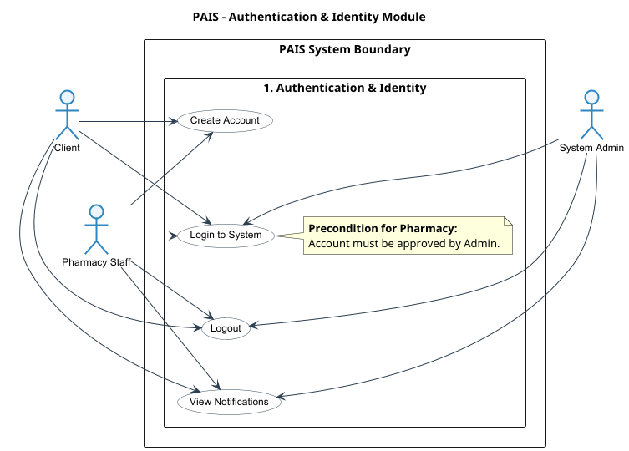Fig(1) Usecase Diagram to Authentication & Identity
Onboarding, Inventory & Governance
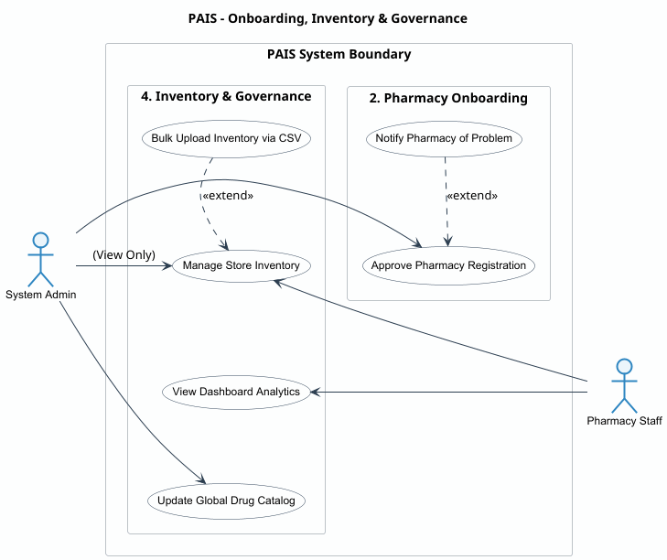Fig(2) Usecase Diagram to Onboarding, Inventory & Governance

Client Drug Discovery Portal
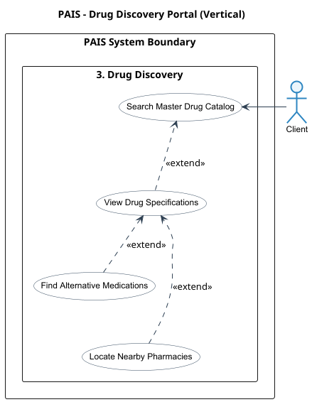
Fig(3) Usecase Diagram to Client Drug Discovery Portal

4.3.2 Sequence Diagrams
Sequence Diagrams illustrate interactions between system components in a time-ordered manner. They trace the real-time, chronological messaging exchanged between the React-based frontend UI, the Node.js API Gateway, the Python AI microservice, and the MongoDB database. These diagrams map out complex operations such as geofenced stock locator requests, token rotation, and generating AI-driven alternative drug recommendations.
User Registration
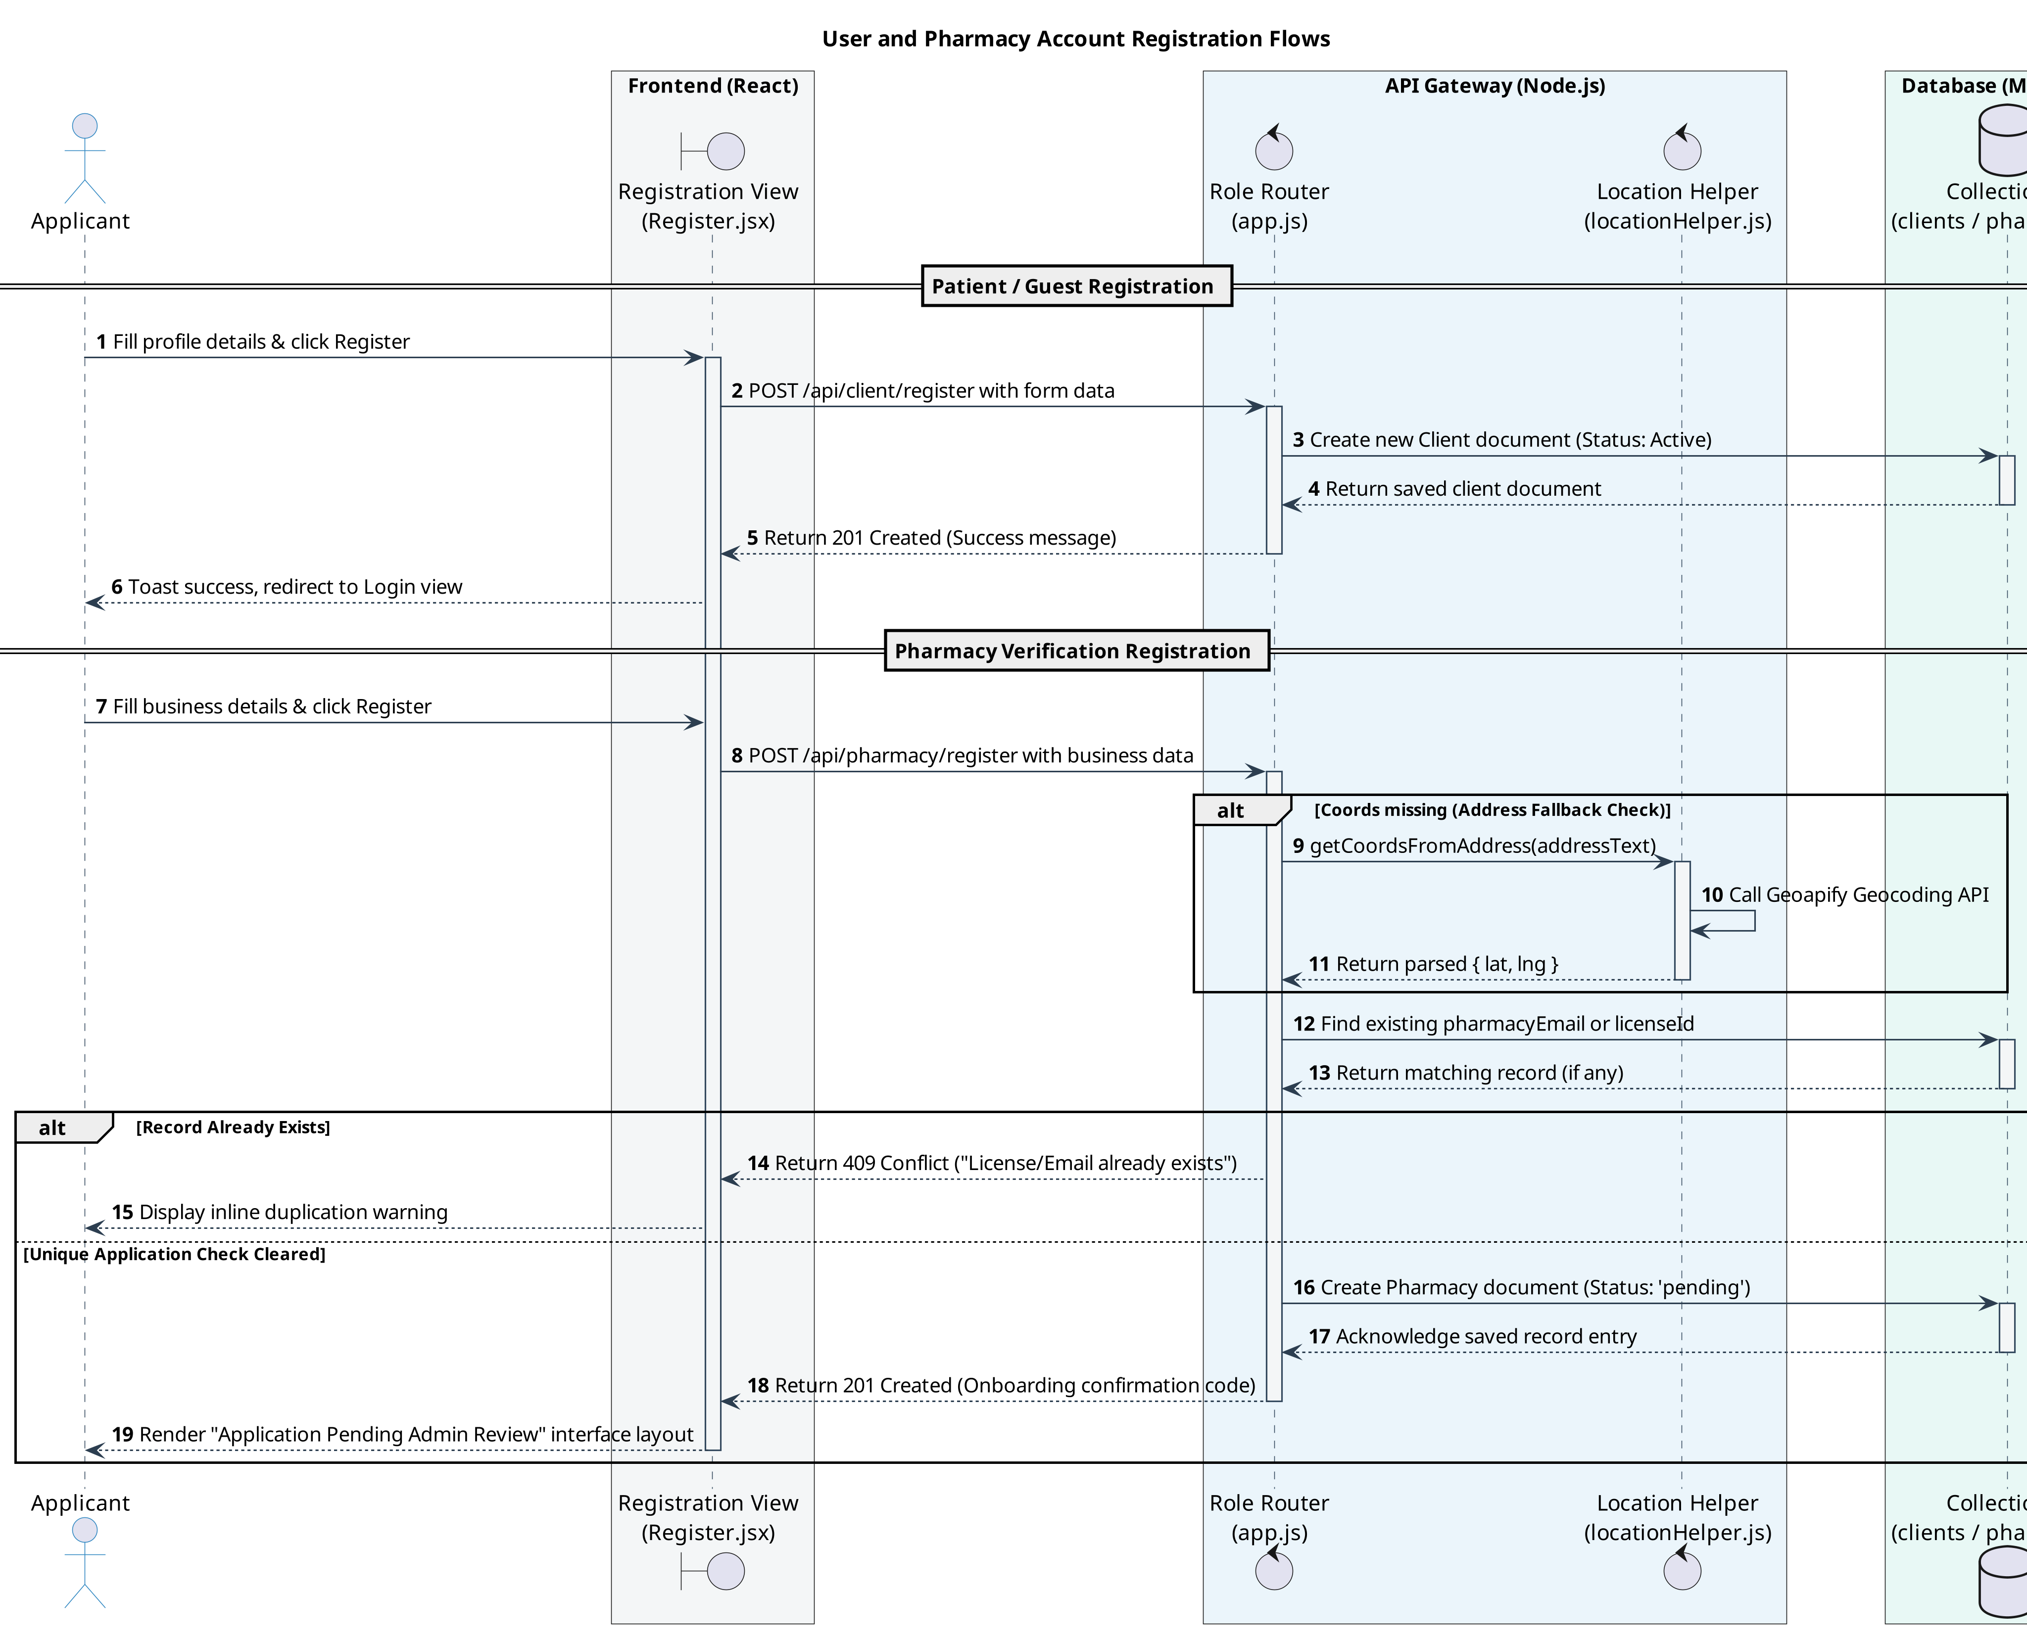Fig(4) Sequence Diagram to User Registration
Login, and Security Gatekeeping
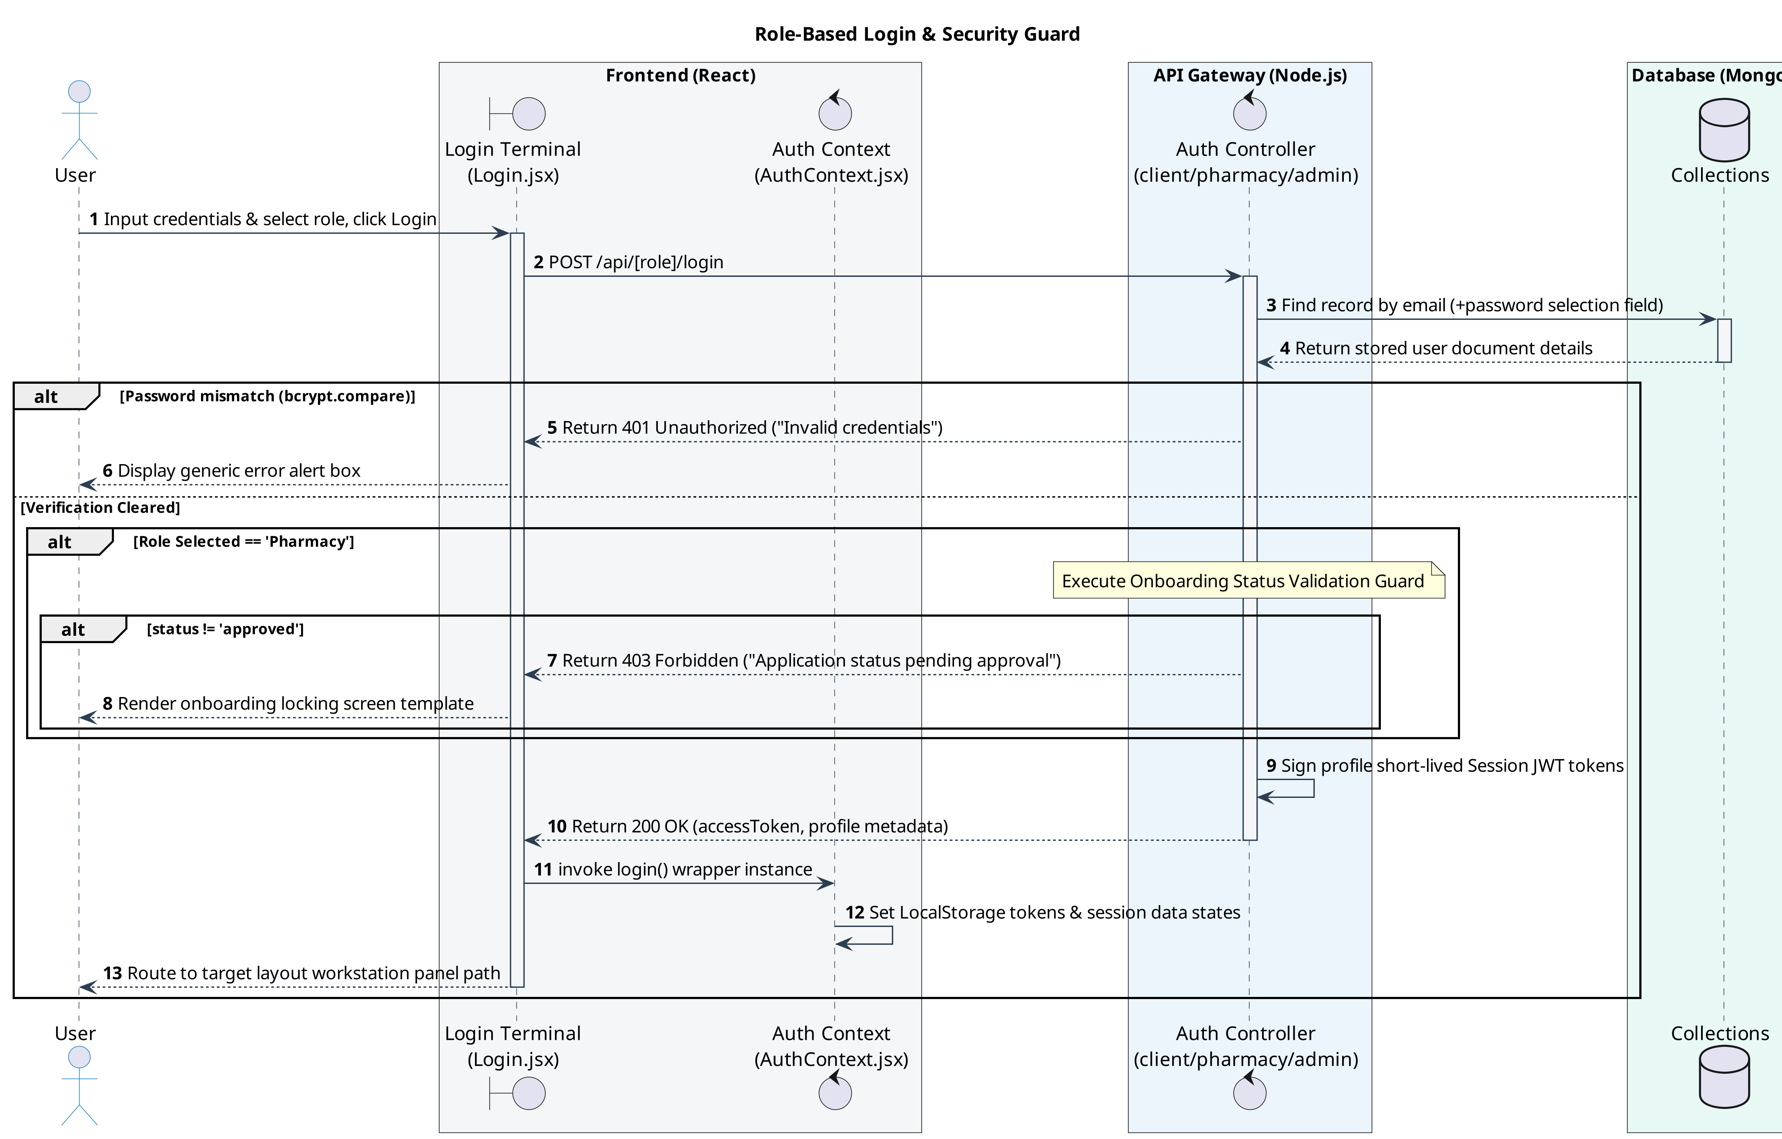Fig(5) Sequence Diagram to Login, and Security Gatekeeping

Client Medicine Search, Geofenced Stock Locator, and AI Alternatives
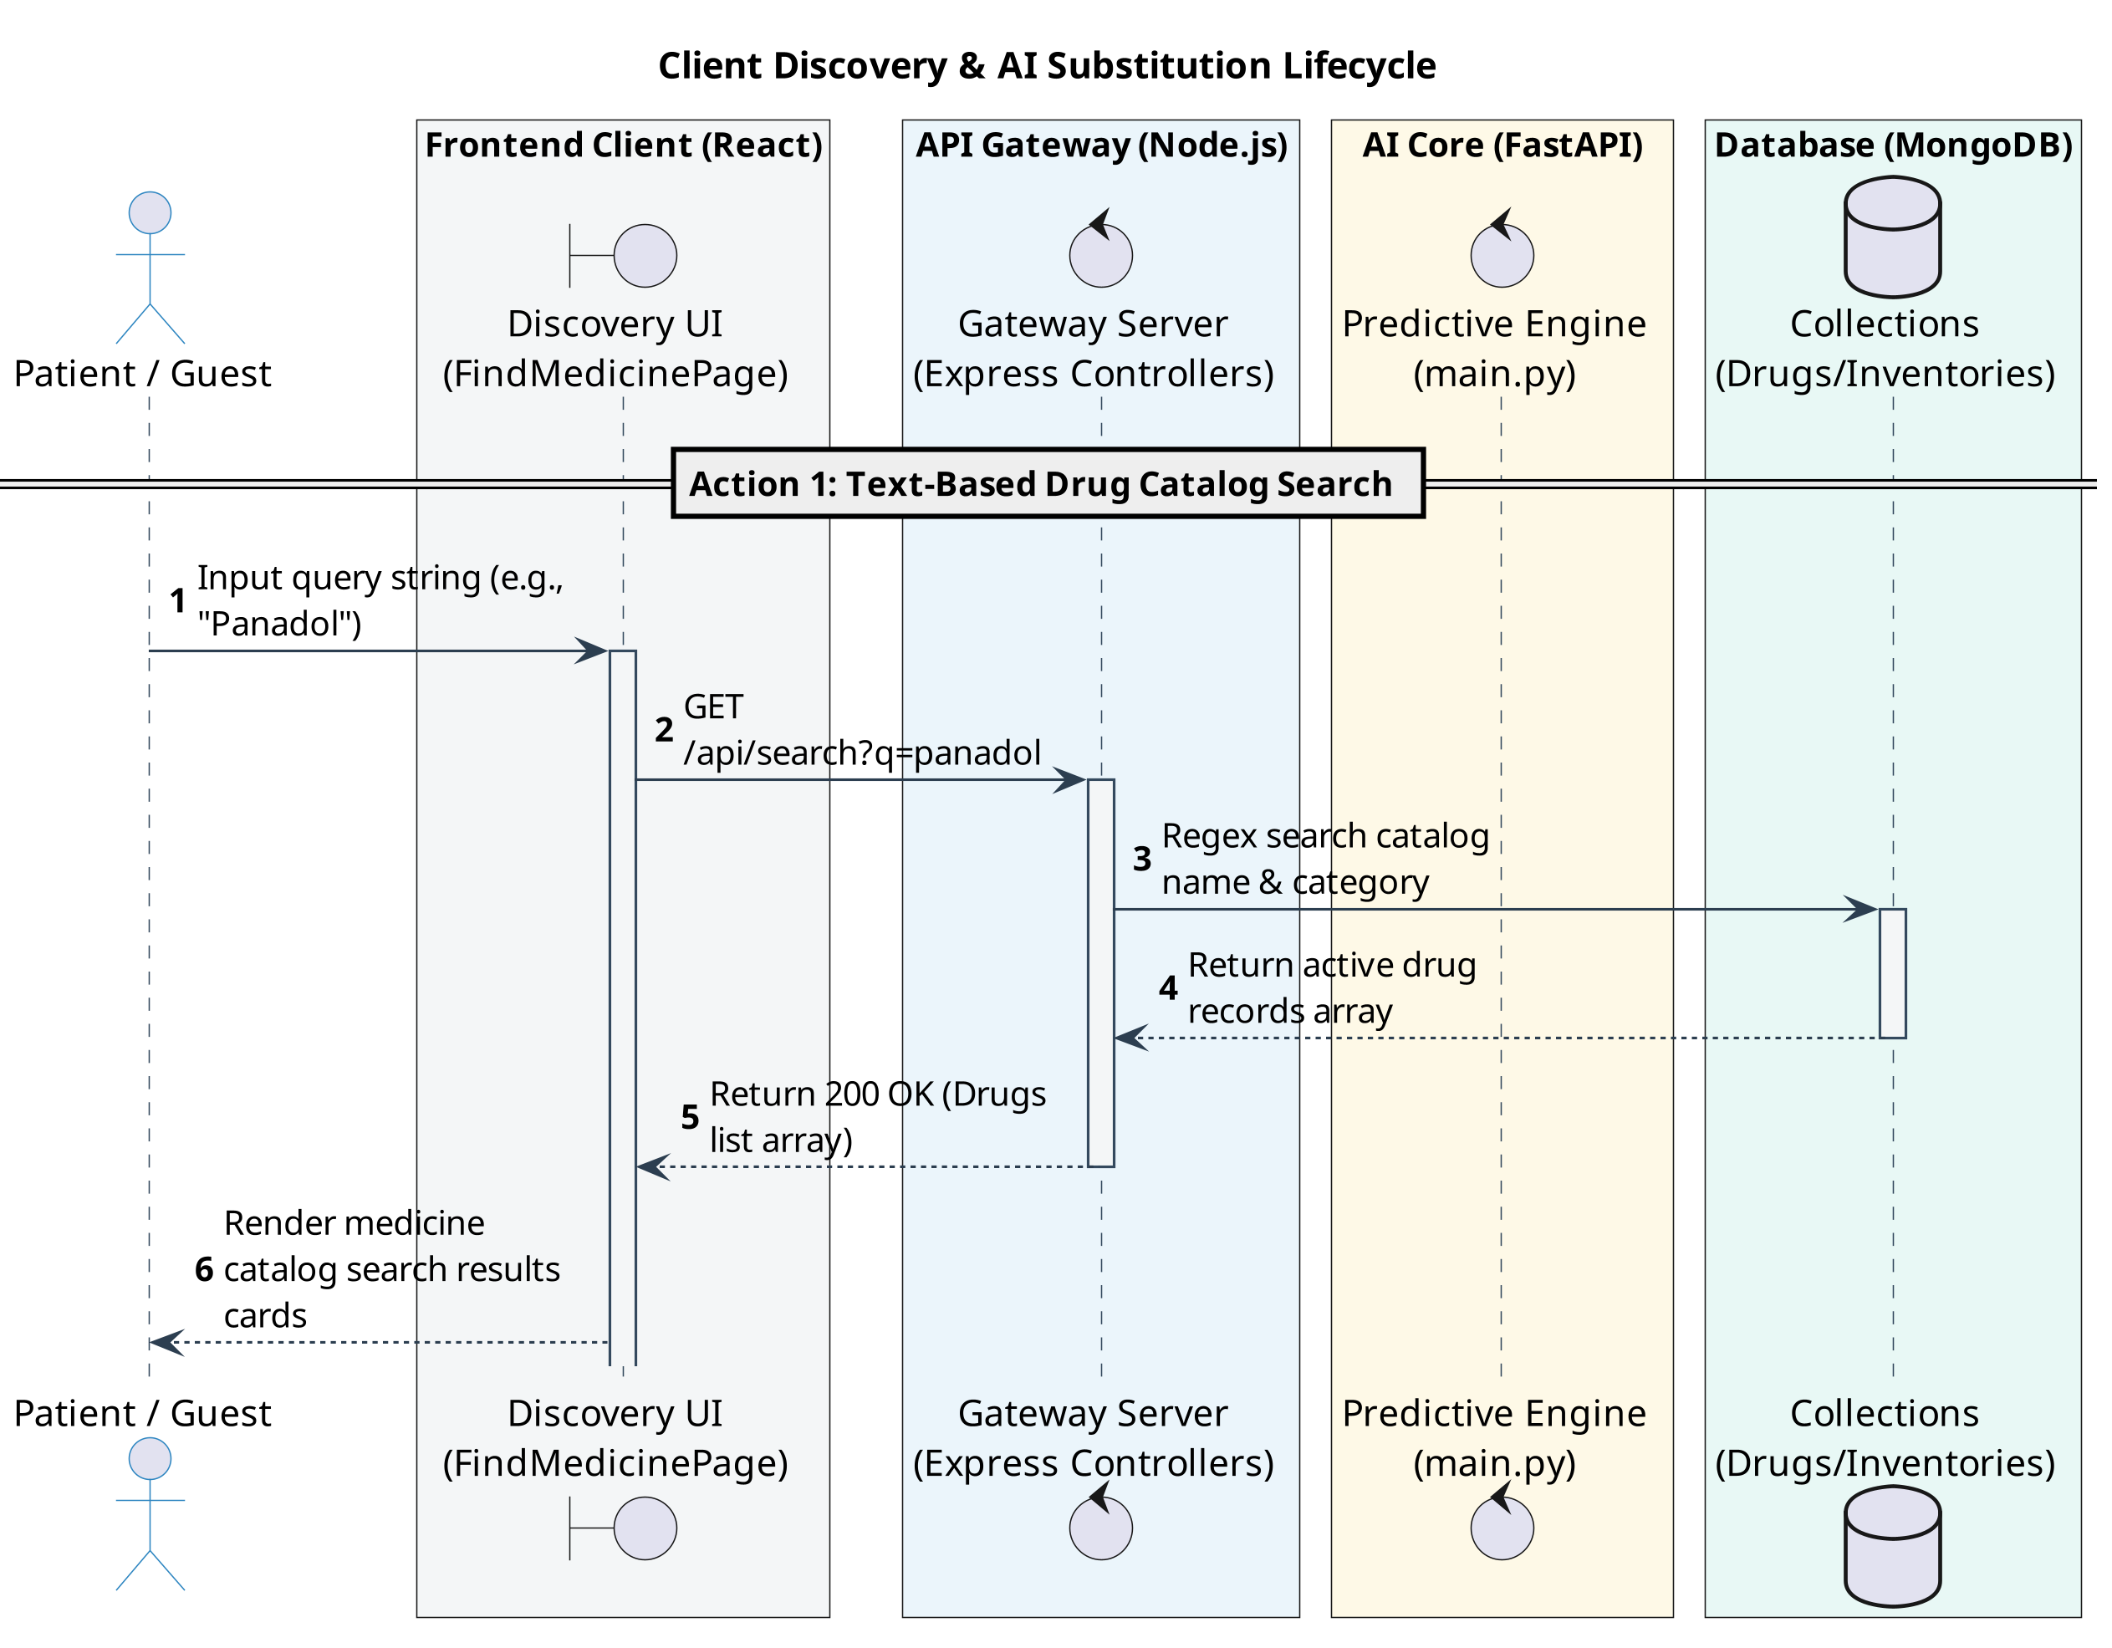Fig(6) Sequence Diagram to Client Medicine Search
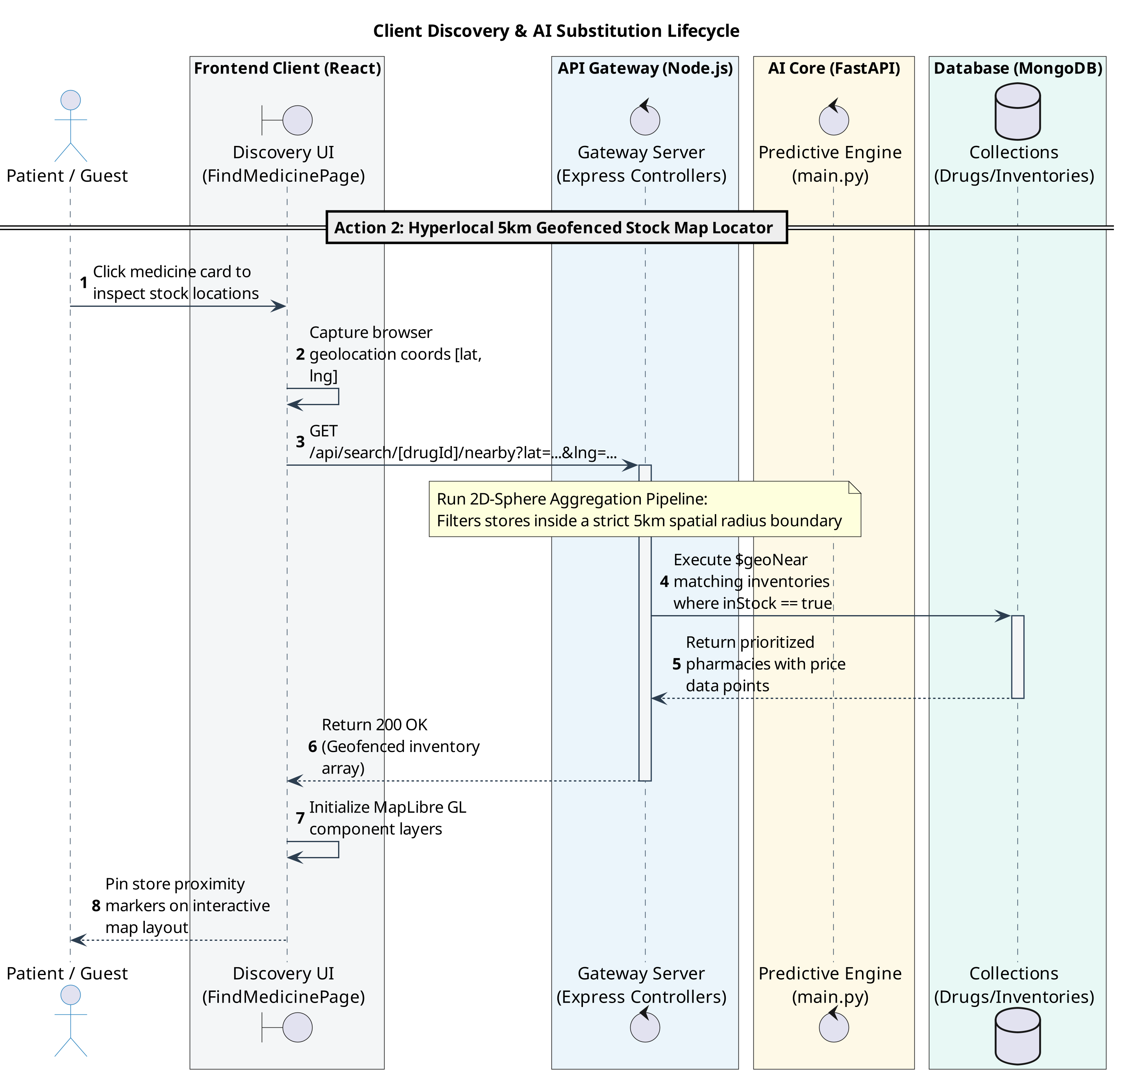Fig(7) Sequence Diagram to Geofenced Stock Locator
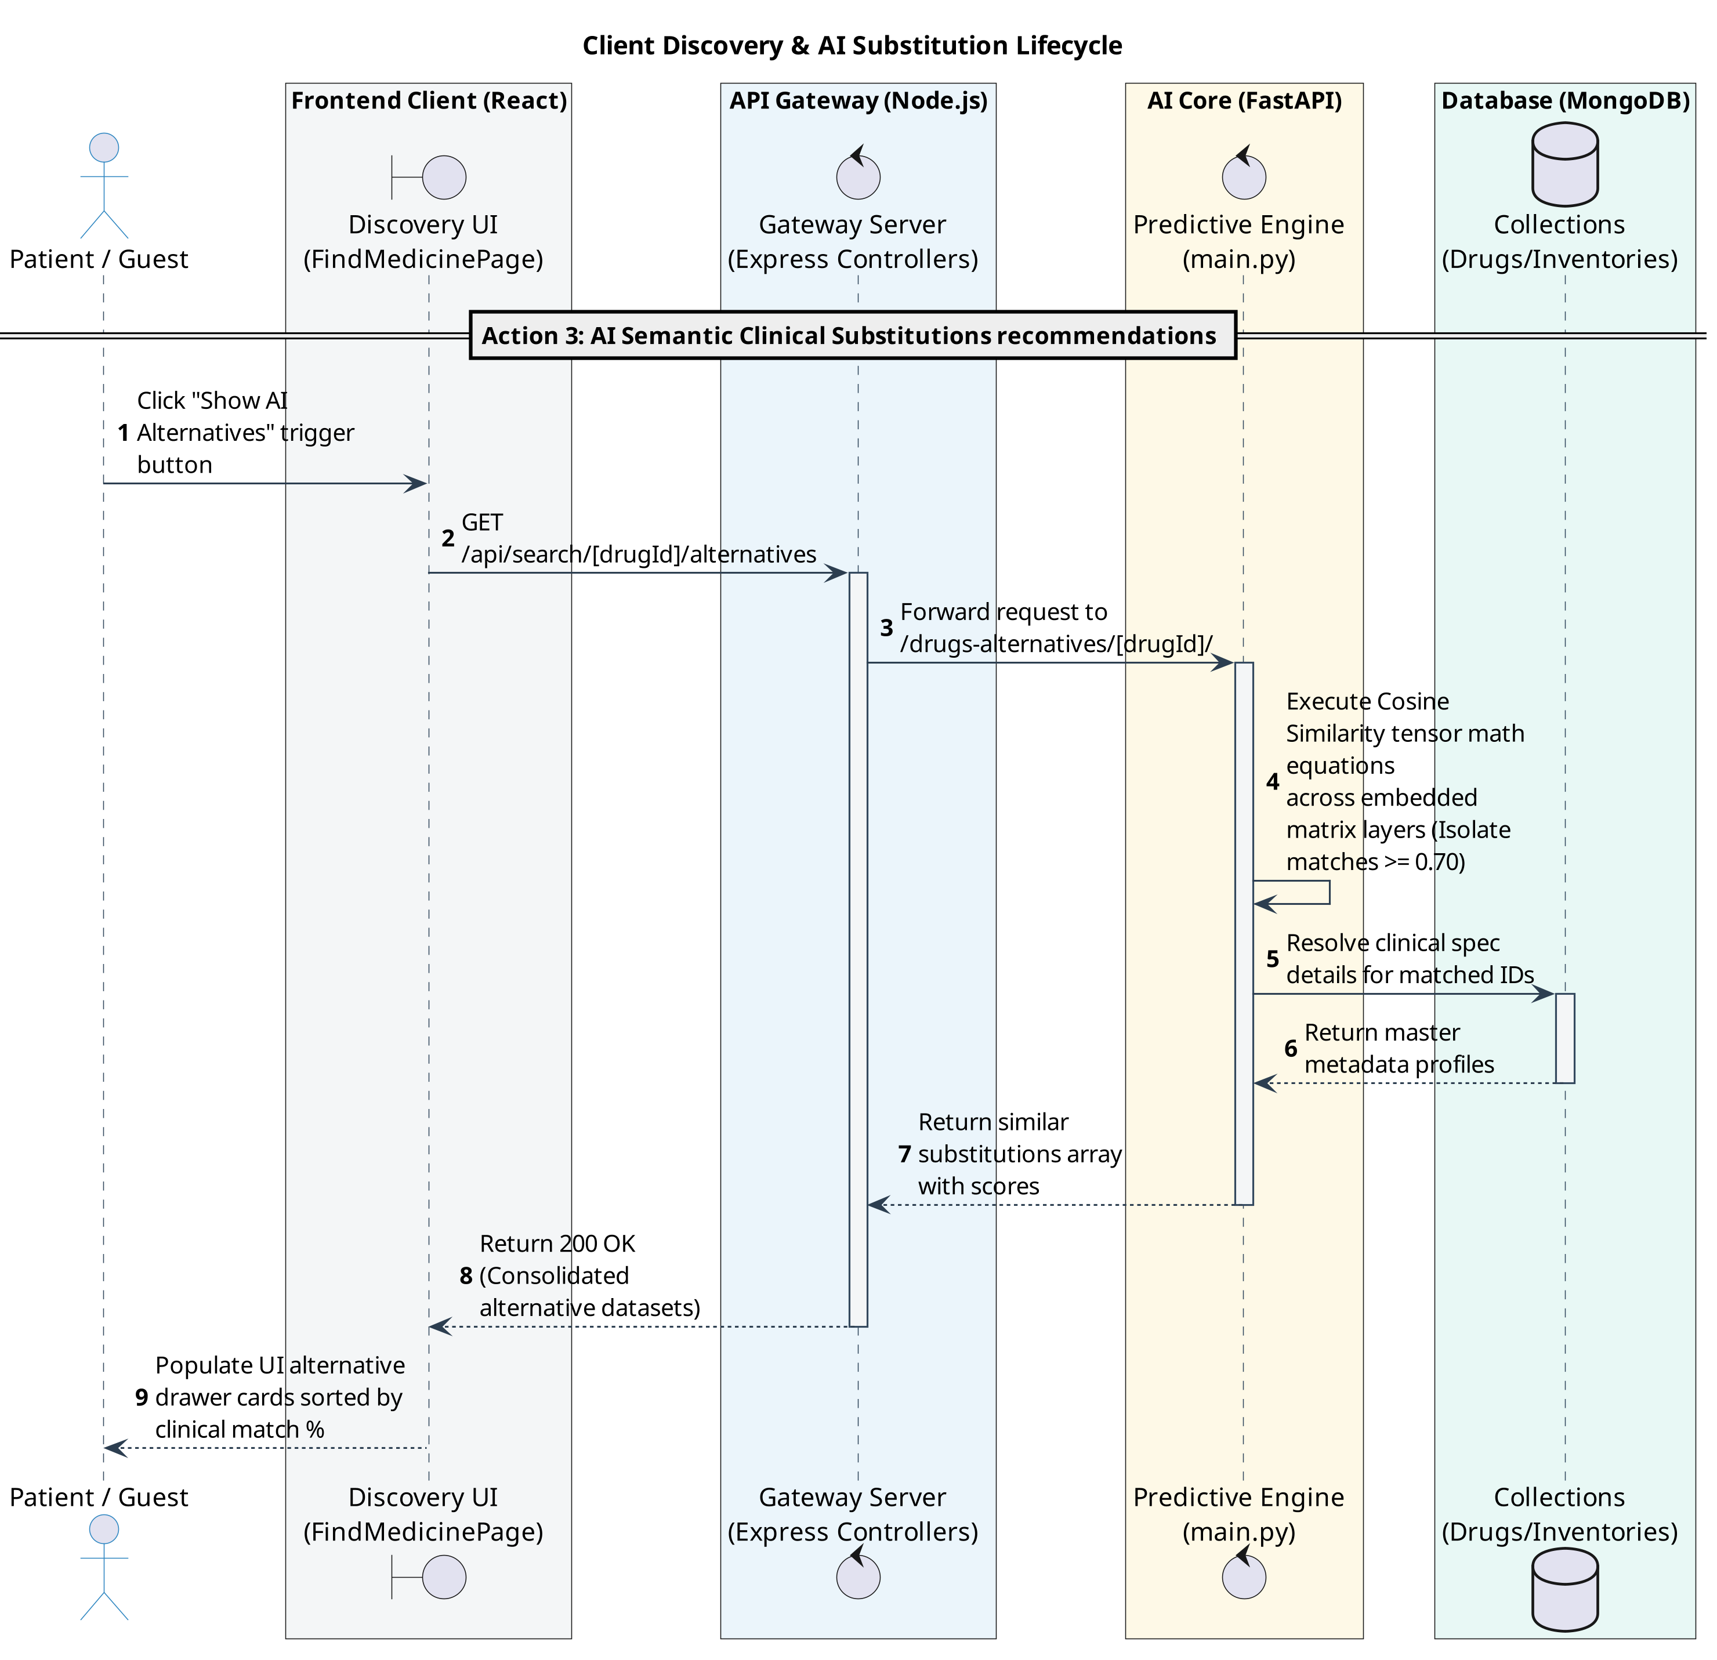Fig(8) Sequence Diagram to AI Alternatives

Pharmacy Stock Management and Parallel AI Analytics Dashboard
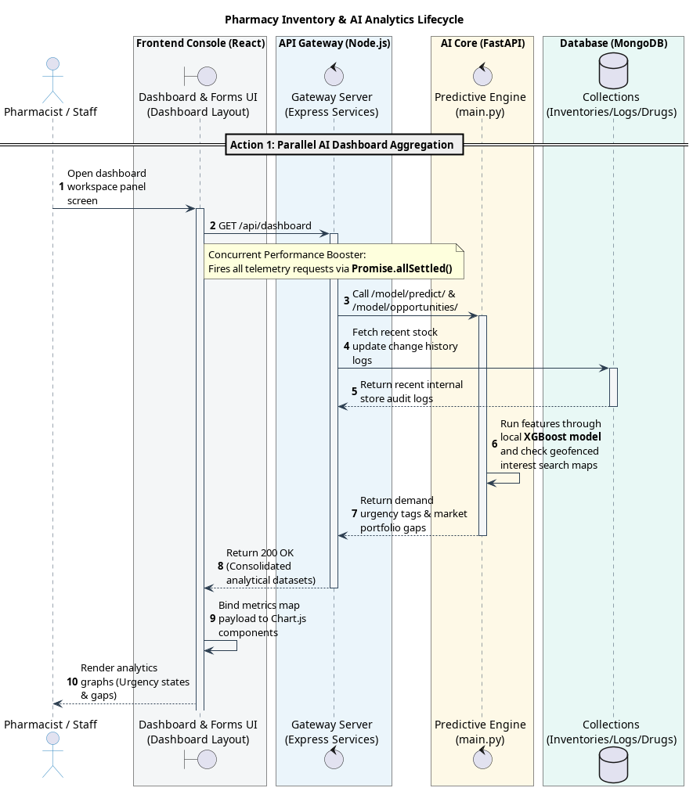Fig(9) Sequence Diagram to Pharmacy AI Dashboard
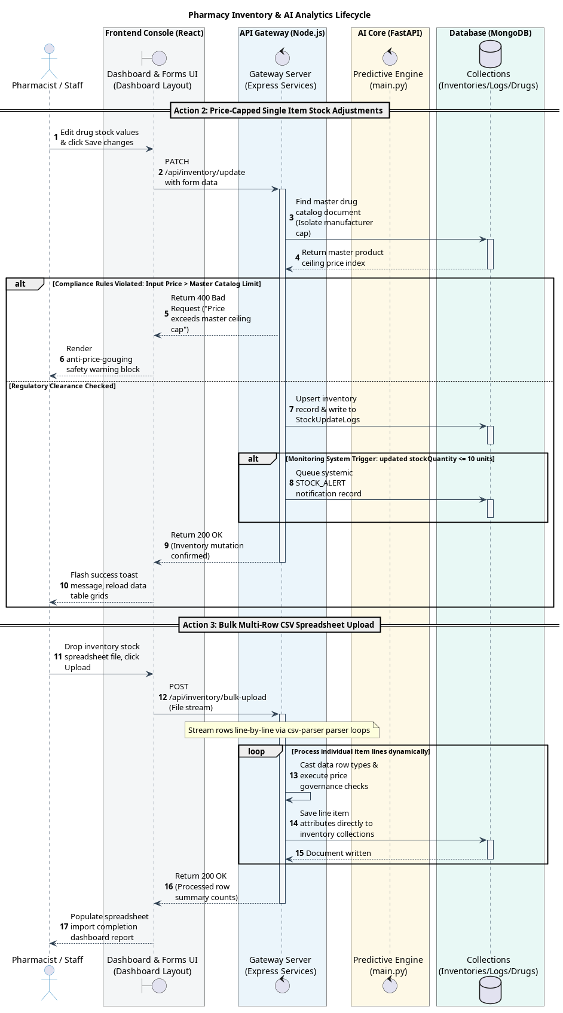Fig(10) Sequence Diagram to Pharmacy Inventory

System Admin License Auditing and Master Catalog Synchronization
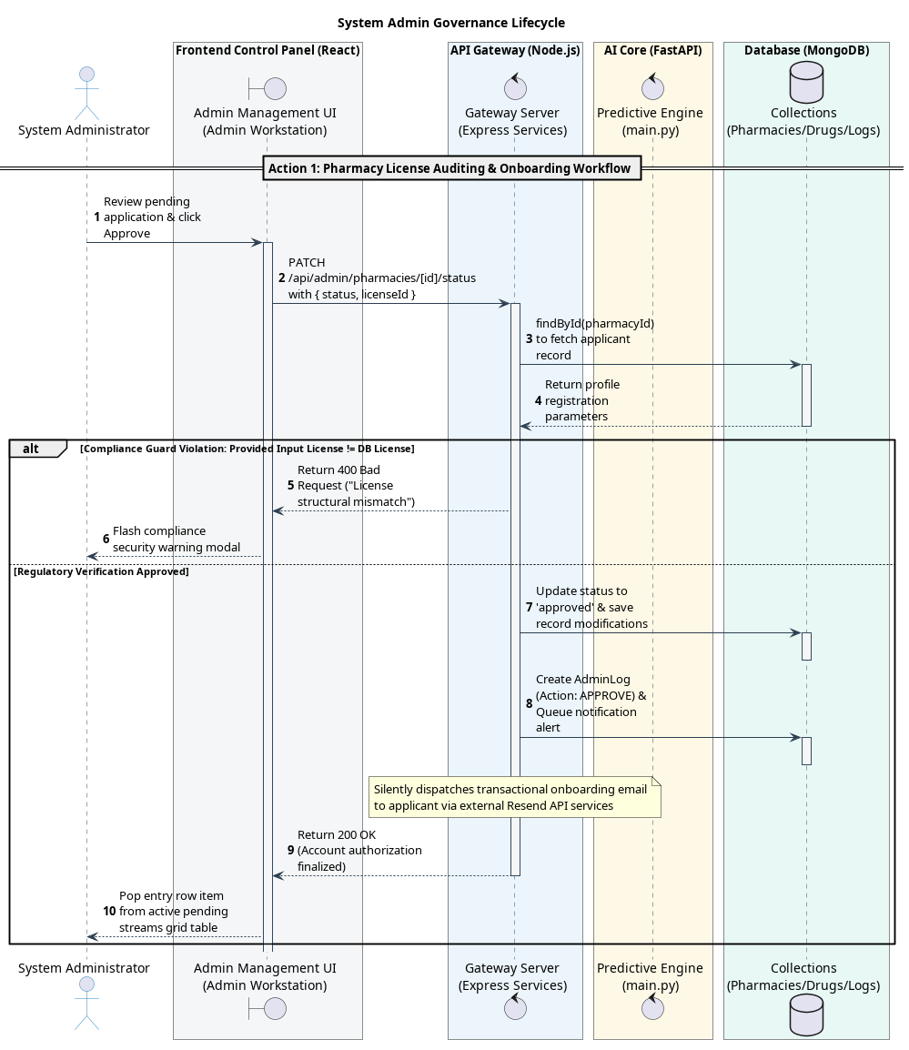Fig(11) Sequence Diagram to System Admin License Auditing
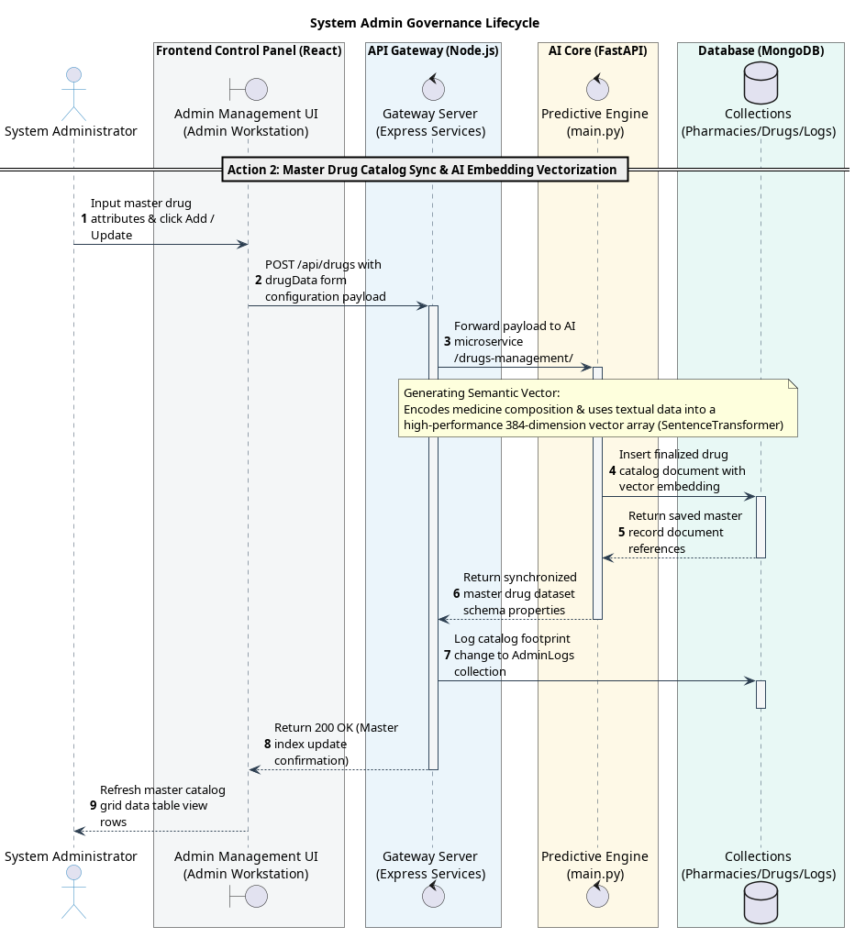Fig(12) Sequence Diagram to Admin Master Catalog Synchronization

4.3.3 Activity Diagrams
Activity Diagrams are used to represent the workflows of key system processes within PAIS. They act as flowcharts that show the step-by-step logic, decision forks, and error handling during main system features. These diagrams help in understanding the logical flow of activities such as user onboarding and registration, role-based login security routing, and pharmacist multi-lane dashboard operations.
User Onboarding and Registration Process
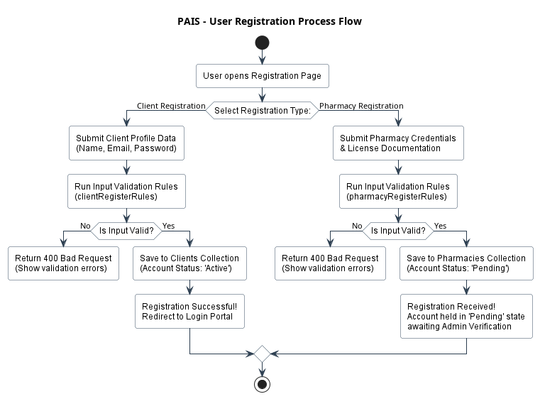Fig(13) Activity Diagram to User Onboarding and Registration Process

Role-Based Login and Security Verification
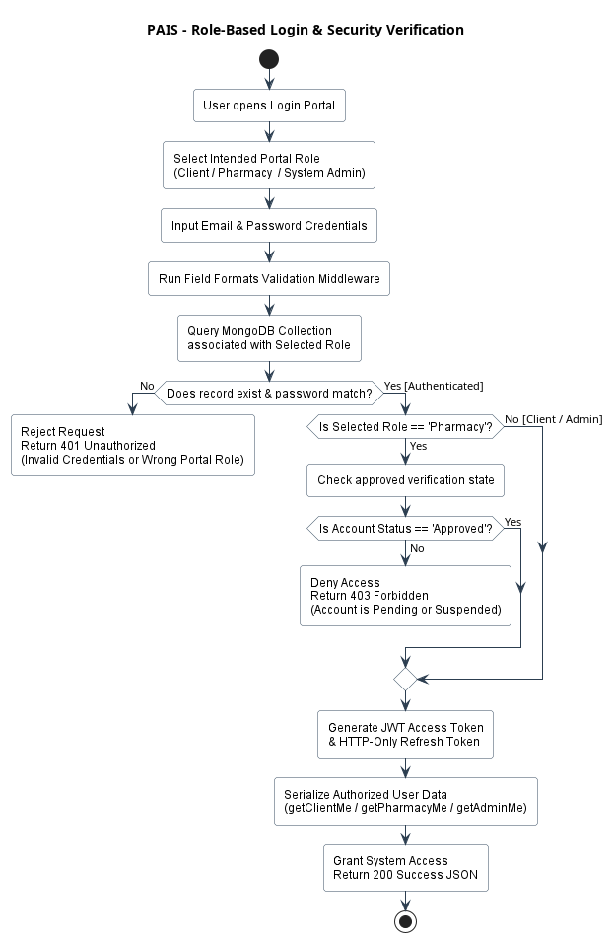Fig(14) Activity Diagram to Role-Based Login and Security Verification

Client Activity Routing
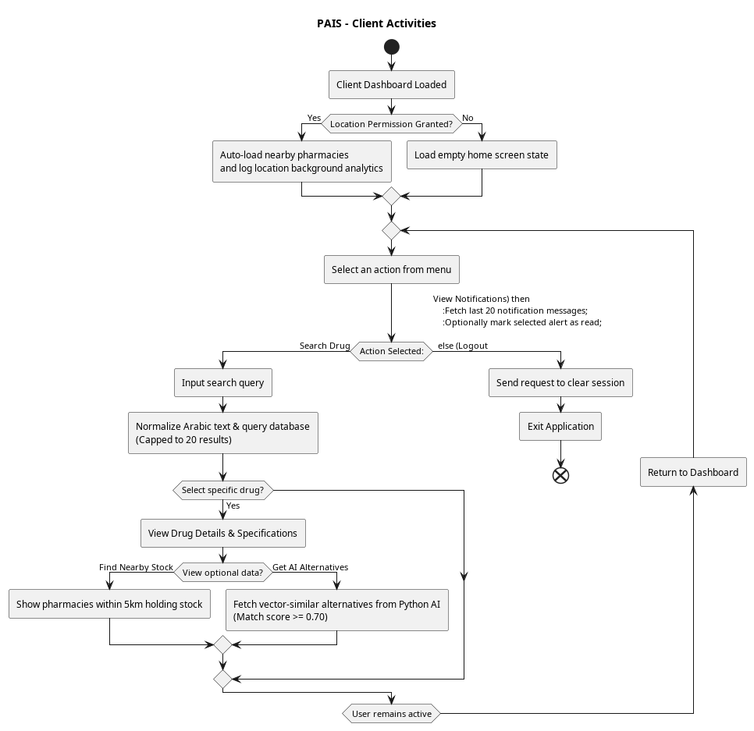Fig(15) Activity Diagram to Client Activity Routing

Pharmacist Multi-Lane Dashboard Operations
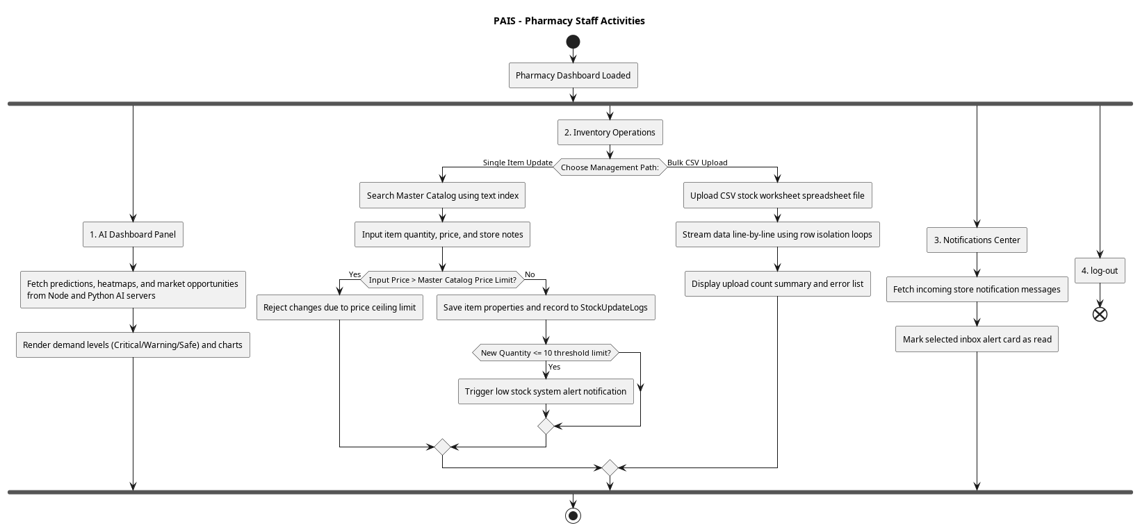Fig(16) Activity Diagram to Pharmacist Multi-Lane Dashboard

System Administrator Control Workspace
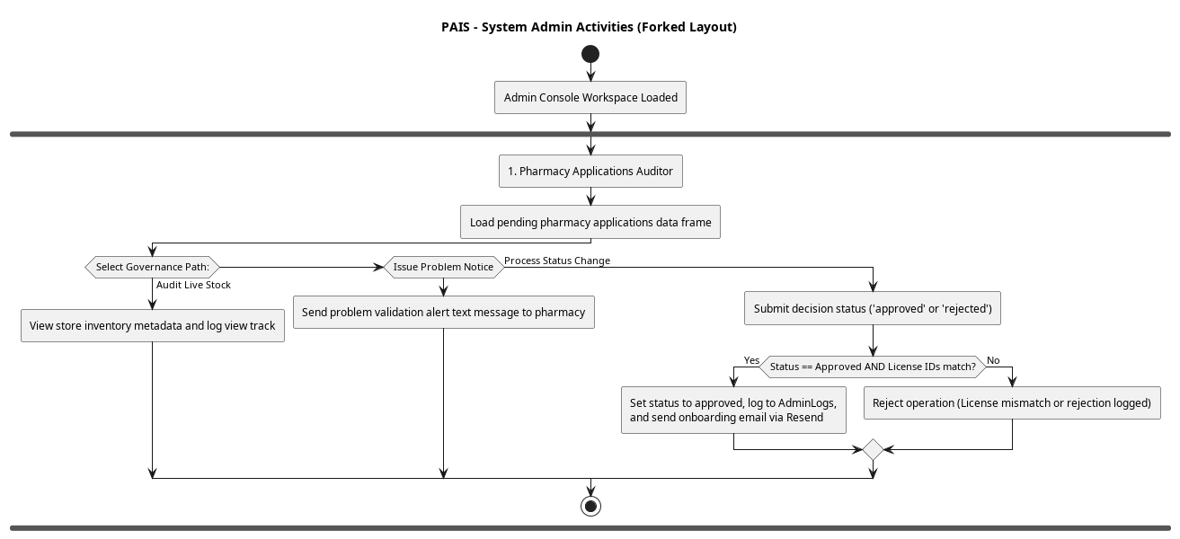
Fig(17) Activity Diagram to Pharmacies manage
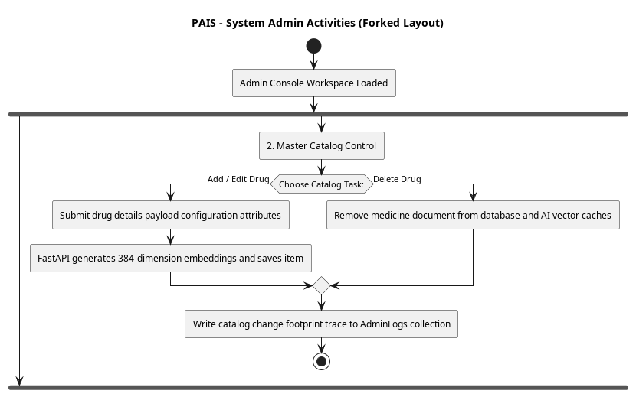Fig(18) Activity Diagram to Drugs data mange
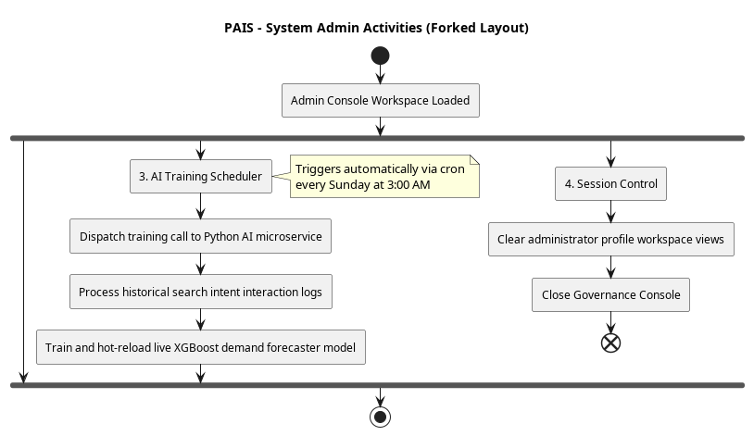Fig(19) Activity Diagram to AI training manage

4.3.4 Class Diagram
The Class Diagram outlines the static structure of the PAIS codebase. It details the specific properties, methods, and software dependencies across the system's various modules, visually representing how classes and components are organized to handle core data models, authentication and security layers, and the integration of the search and AI subsystems.
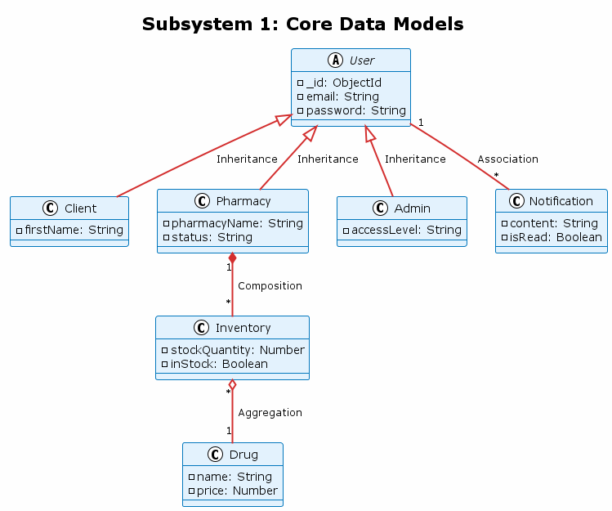Fig(20) Class Diagram to Core Data models

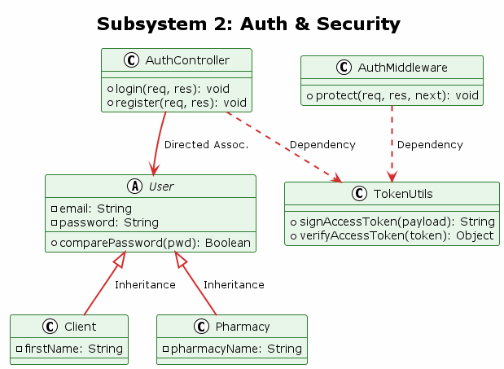
Fig(21) Class Diagram to Auth & Security
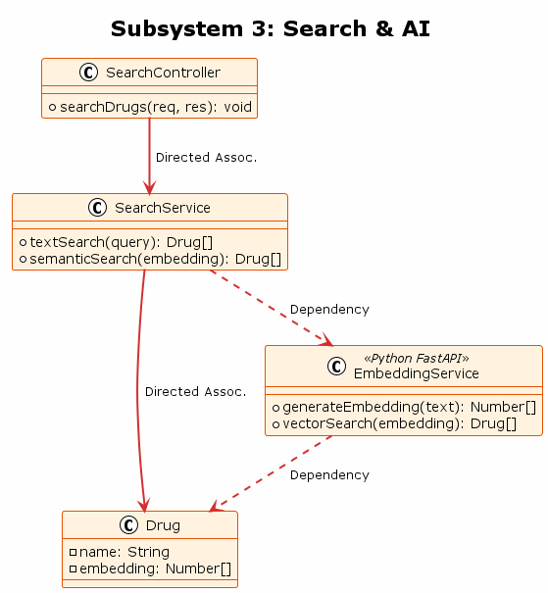Fig(22) Class Diagram to Search & AI
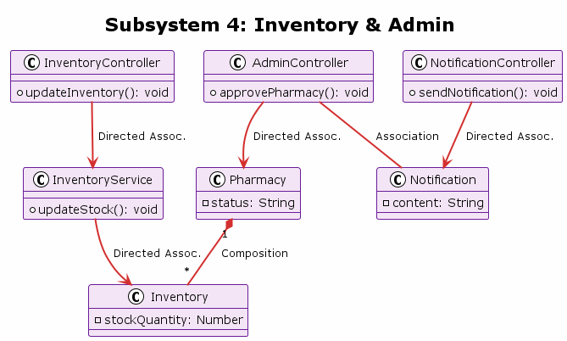Fig(23) Class Diagram to Inventory & AI

4.3.5 ERD Diagram
The Entity-Relationship Diagram (ERD) maps the physical schema of the system's database. It visually demonstrates how system information is organized into dedicated MongoDB collections—such as Clients, Pharmacies, Drugs, Inventories, and Logs—and shows how these data structures link together using clear database notation and object identification keys.
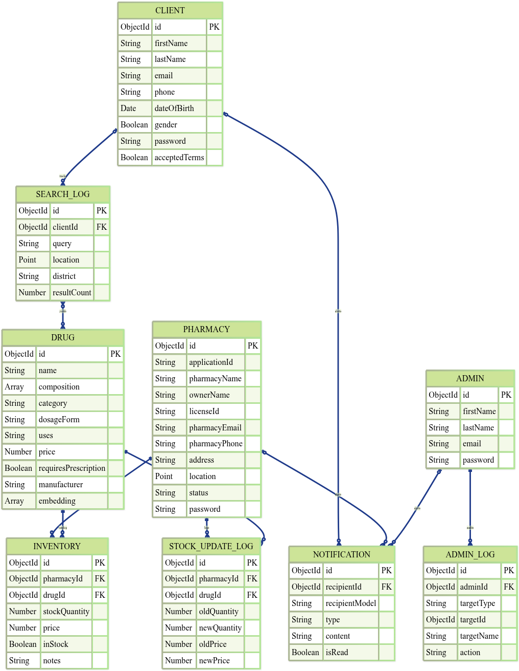
Fig(24) ERD Diagram to System Database

CHAPTER FIVE | SYSTEM IMPLEMENTATION

5.1 Overview
This chapter outlines the practical realization of the Pharmaceutical Artificial Intelligent System (PAIS). It translates the architectural blueprints and four-tier system models discussed in Chapter Four into a functional, deployed software solution. The implementation is categorized into four primary domains mirroring the system design: the React-based Frontend (Presentation Tier), the Node.js Backend (API Gateway), the Python-driven Artificial Intelligence microservice (AI Coprocessor), and the MongoDB infrastructure (Data Persistence). The following sections detail the frameworks, libraries, and coding methodologies utilized to satisfy the platform's functional and non-functional requirements.

5.2 Frontend Implementation
The presentation layer of PAIS is constructed as a high-performance Single Page Application (SPA). The frontend prioritizes a responsive user experience, utilizing modern JavaScript ecosystems to ensure rapid rendering and seamless state synchronization.
- Core Framework & Build Tool: The application is built using React.js (v19) and scaffolded with Vite to leverage Hot Module Replacement (HMR) and optimized build performances.
- Styling & UI Components: Visual design is executed via Tailwind CSS for utility-first, responsive styling. Complex interactive elements (like cards, modals, and buttons) are implemented using the @heroui/react component library, supplemented by lucide-react for consistent iconography.
- State Management & Routing: Application state, specifically role-based authentication, is managed globally using React's Context API (AuthContext.jsx). Navigation is handled by react-router-dom, utilizing a ProtectedRoute wrapper to conditionally block or grant access based on JWT validation and user roles (Client, Pharmacy, Admin).
- HTTP Client & Interceptors: Axios is utilized for asynchronous server communication. A custom configuration (axiosWithRefresh.js) acts as a middleware interceptor; if an API call returns a 401 Unauthorized status, it automatically pauses the request, securely fetches a new access token using the stored refresh token, and replays the original request transparently to the user.
- Geospatial Rendering: Interactive maps for locating nearby pharmacies are implemented using MapLibre GL (MapComponent.jsx), mapping GeoJSON coordinate data to dynamic UI markers.
[INSERT FIGURE 25: Frontend Architecture Diagram HERE]

5.3 System User Interfaces (Screenshots)
The following figures illustrate the implemented user interfaces of the PAIS platform, demonstrating the home screen, medicine search functionalities, geospatial mapping, and the dynamic analytics dashboards utilized by clients and pharmacists.

5.4 Backend Implementation
The backend serves as the core operational hub, built on a robust, asynchronous JavaScript runtime environment capable of handling high-volume concurrent requests.
- Server Architecture: The application runs on Node.js utilizing the Express.js framework. It strictly adheres to a Model-Route-Controller-Service (MRCS) architecture to enforce a clean separation of concerns between HTTP routing and core business logic.
- Security & Authentication: User authentication is implemented using JSON Web Tokens (JWT), generating both short-lived access tokens and long-lived refresh tokens. Passwords are cryptographically hashed using bcryptjs prior to database insertion. Route protection is enforced via custom Express middleware (auth.js), which decodes the Bearer token and applies Role-Based Access Control (RBAC). Furthermore, incoming API payloads are sanitized and validated using express-validator to prevent injection attacks.
- Inventory Processing: To accommodate large-scale pharmacy stock updates, the system utilizes Multer to handle multipart/form-data. CSV files are parsed efficiently using csv-parser, allowing the controller to execute rapid, iterative upsert operations on the database.
- Automated Task Scheduling: A localized chron-job system is implemented using node-cron (schedulerService.js). This script is programmed to trigger the Python AI engine every Sunday at 3:00 AM, automatically initiating the retraining sequence for the demand forecasting models based on the week's accumulated search logs.

5.5 Artificial Intelligence & Machine Learning Implementation
The predictive and analytical capabilities of PAIS are isolated into a dedicated Python microservice, ensuring heavy computational tasks do not block the Node.js event loop.
- Microservice Framework: The AI engine is hosted via FastAPI, chosen for its high execution speed and native asynchronous support. It interfaces with the MongoDB database directly using the Motor (AsyncIOMotorClient) driver.
- Semantic Alternative Suggestions: Instead of relying on rigid, text-based matching, the system utilizes sentence-transformers (specifically the all-MiniLM-L6-v2 model). When a drug is added to the catalog, the Python engine generates a high-dimensional vector embedding based on its active composition and uses. When a patient requests an alternative, a cosine-similarity search is executed against these vectors to return scientifically valid, percentage-scored medication alternatives.
- Demand Forecasting & Market Insights: The predictive dashboard relies on an XGBoost machine learning model (pais_demand_forecaster.pkl). By ingesting historical SearchLog coordinates and StockUpdateLog deltas, the model calculates a localized trend analysis. It flags critical low-stock items based on projected local demand and identifies 'Market Opportunities'—drugs frequently searched for in a pharmacy's geographical radius that they do not currently stock.

5.6 Database Implementation
The data layer is managed utilizing a NoSQL database structure, optimized for flexibility, rapid read operations, and complex geospatial calculations.
- Database Engine: MongoDB Atlas is utilized as the cloud-hosted database, with Mongoose serving as the Object Data Modeling (ODM) library within the Node.js environment to enforce schema validation and strict typing.
- Geospatial Indexing: To facilitate the core feature of finding nearby medicines, the Pharmacy and SearchLog schemas implement a location object strictly formatted as a GeoJSON Point ([longitude, latitude]). A 2dsphere index is applied to these fields, enabling the system to execute rapid $near aggregation pipelines.
- Text Indexing for Search: The Drug catalog implements compound text indexes across the name, composition, and uses fields. This allows the master search controller to execute weighted, natural language queries seamlessly.
- Relational Integrity: While operating in a NoSQL environment, data integrity is maintained through compound unique indexes. For instance, the Inventory collection enforces a unique constraint on the combination of { pharmacyId: 1, drugId: 1 }, physically preventing duplicate stock records for the same medication at a single location.

CHAPTER SIX | TESTING

6.1 Overview
[INSERT: Comprehensive description of testing strategy, testing phases, and objectives]

6.2 System Testing

6.2.1 Unit Testing
[INSERT: Unit testing approach and results]
Module | Test Cases | Passed | Failed | Pass Rate
[MODULE 1] | [#] | [#] | [#] | [#]%
[MODULE 2] | [#] | [#] | [#] | [#]%

6.2.2 Integration Testing
[INSERT: Integration testing approach and results]

6.3 User Testing
[INSERT: UAT scenarios and usability testing feedback]

6.4 Testing Summary
[INSERT: Overall testing outcomes and recommendations]

CHAPTER SEVEN | CONCLUSION & FUTURE WORK

7.1 Overview
This chapter presents the final outcomes and overall evaluation of the Pharmaceutical Artificial Intelligent System (PAIS).

7.2 Conclusion
The Pharmaceutical Artificial Intelligent System (PAIS) was developed to address the significant challenge of medication accessibility in the pharmaceutical retail sector. Through integration of artificial intelligence, geospatial tracking, and modern cloud-based technologies, the project successfully provides a centralized platform connecting patients, pharmacies, and administrators within a secure and scalable environment.

7.3 Future Work
- Real-Time Supplier & Distributor APIs: [INSERT: Details about automatic synchronization]
- Mobile Applications: [INSERT: Native Android/iOS development plans]
- E-Prescription Support: [INSERT: Healthcare integration plans]
- Advanced Cloud Infrastructure: [INSERT: Scalability improvements]
- Barcode & QR-Code Scanning: [INSERT: Hardware integration details]

REFERENCES LIST
[INSERT REFERENCES: Academic papers, books, online resources, and technical documentation. Include at least 20-30 references related to: - Pharmacy management systems - Machine learning and demand forecasting - Natural language processing - Web technologies (React, Node.js, MongoDB) - Geospatial systems - Security and authentication - Healthcare informatics]

Format Examples:
- [Author Name], "[Paper Title]," Journal Name, Year, pp. [pages].
- [Author Name], Book Title, Publisher, Year.
- [Website/Source], "Title," Retrieved from [URL], Accessed on [Date].

END OF DOCUMENT

